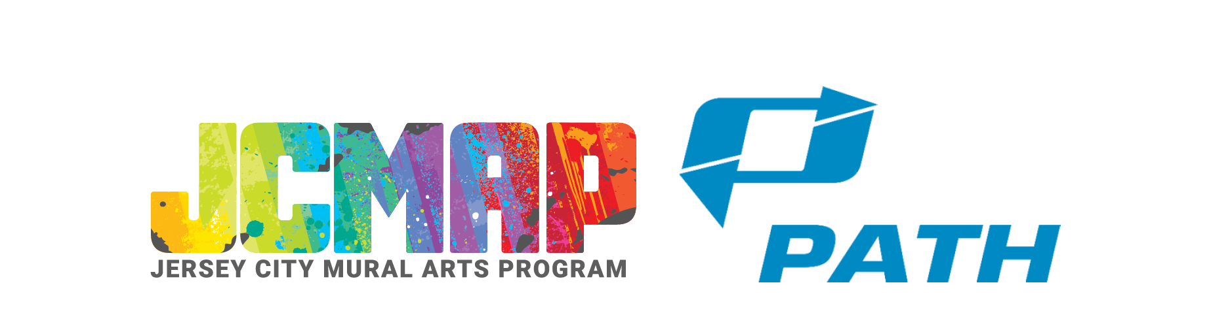

EXHIBIT A

Categories of images that PATH will not approve for display

PATH shall reject an image that meets one or more of the below characteristics:

- i. Demeaning or disparaging. The image contains material that demeans or disparages an individual or group of individuals. For purposes of determining whether an image contains such material, the decision maker acting on behalf of PATH in accordance with these guidelines will determine whether a reasonably prudent person, using prevailing community standards, would believe that the image contains material that ridicules or mocks, is abusive or hostile to, or debases the dignity or stature of, an individual or group of individuals.

- ii. Tobacco. The image promotes the sale or use of tobacco or tobacco-related products, including depicting such products.

- iii. Profanity. The image contains profane language.

- iv. Violence. The image contains an image or description of graphic violence, including, but not limited to (1) the depiction of human or animal bodies or body parts, or fetuses, in states of mutilation, dismemberment, decomposition, or disfigurement, and (2) the depiction of weapons or other implements or devices used in the advertisement in an act or acts of violence or harm on a person or animal.

- v. Unlawful goods, services or conduct. The image, or any material contained in it, promotes or encourages, or appears to promote or encourage, unlawful or illegal behavior or activities, including but not limited to any unlawful or illegal action based on a person’s race, color, religion, disability, national origin, ancestry, sexual orientation, marital or parental status, military service, discharge status or sources of income.

- vi. Nudity. The image contains depictions of unclothed or uncovered human genitals, buttocks or the female breast below a point immediately above the top of the areola, or the covered male genitals in a discernibly turgid state.

- vii. Obscenity. The image contains obscene material that depicts patently offensive or excretory activities so as to satisfy the definition of obscene material as contained in New York Penal Law § 235.00 or N.J.S.A. 2C:34-2, as amended from time to time.

- viii. Distribution of Obscenity to Minors. The image contains material which, if sold or loaned to a minor with knowledge of its character and content, would give rise to a violation of New York Penal Law §§ 235.20 et. seq. or N.J.S.A. 2C:34-3, as amended from time to time.

- ix. Prurient sexual suggestiveness. The image contains material that describes, depicts, or represents sexual activities or aspects of the human anatomy in a way that the average adult, applying contemporary community standards, would find appeals to the prurient interest of minors or adults in sex. For purposes of these guidelines, the term “minor” shall mean a person under eighteen (18) years of age.

- x. Sexual suggestiveness of minors. The image contains an image of a person who appears to be a minor in a sexually suggestive dress, pose, or context.

- xi. “Adult”-oriented goods or services. The image promotes or encourages, or appears to promote or encourage, a transaction related to, or uses brand names, trademarks, slogans or other materials which are identifiable with, films rated “X” or “NC-17,” nude dance clubs, adult telephone services, escort services and establishments, stores and internet sites selling materials described in sections (viii-ix).

- xii. Political campaign, political issue or religious speech. The image (1) refers to a specific ballot question, initiative petition, or referendum, (2) refers to any candidate for public office, (3) refers to a political issue, regardless of viewpoint, or (4) contains or promotes a religious message, regardless of viewpoint.

- xiii. Adverse to PATH. The image, or material contained or used in it, is directly adverse to the commercial or administrative interests of PATH, or that tends to disparage the quality of service provided by PATH, or that tends to disparage public/mass transportation generally.

- xiv. Endorsement. The image, or any material contained or used in it, implies or declares an endorsement by PATH, the Port Authority of New York and New Jersey (“the Port Authority”), or either the states of New York or New Jersey, of any service, product, or point of view, without prior written authority of PATH or a duly authorized representative of either the States of New York or New Jersey. PATH reserves the right to require that an image on or in its Facilities include a prominent disclaimer indicating that it is not sponsored by, and does not necessarily reflect the views of, PATH, the Port Authority or either the States of New York or New Jersey.

- xv. False, misleading, or deceptive speech. The image, or any content thereof, is false, misleading, or deceptive in any material respect.

- xvi. Libelous speech, copyright infringement, violation of law. The image or any material contained or used in it, is libelous or an infringement of copyright, or is otherwise in violation of applicable law in the jurisdiction in which it is to be displayed.

- xvii. Unsafe behavior. The image encourages or depicts unsafe behavior with respect to driving, commuting or transit-related activities, such as the non-use of normal safety precautions in driving, or awaiting, boarding, riding upon or disembarking from transit vehicles.

